Extranet Android App
User FAQ

Table of Contents
> Objective: 2
> Pre-Requisite: 2
> How to Download Route? 2
> How to set Background Reading for Route? 3
> How to set Route Inspection Date? 4
> How to view All / Inspected / UnInspected Subarea of Route? 5
> How to set Background Reading for Subarea? 6
> How to view Inspected / UnInspected Components for the SubArea? 7
> How to Mark All Components Inspected in SubArea? 8
> How to search for Component? 9
> How to enter Screening Value for Components? 10
> How to enter Component Leak Summary? 11
> How to enter Component Leak Repairs? 12
> How to upload Route? 13
> How to create New Inspection? 14
> How to pair TVA with Handheld Mobile Device? 15
> How to connect paired TVA with Handheld Mobile Device? 16

> Objective:
This document will be guide for Extranet Android App Users.

> Pre-Requisite:
User should have mobile phone device with Extranet Android App installed. The user should know how to launch the Extranet Android App.

> How to Download Route?
Navigate to Download Tab on Routes Screen. Enter the WO (Work Order) Number.
Tap on the Magnifying Glass button on the keypad.

The Routes for the WO will be displayed. Tap on the Route which you want to download. A confirmation message box "Do you want to Download <Name> Route?" will be displayed. Tap on Yes button to download the route.
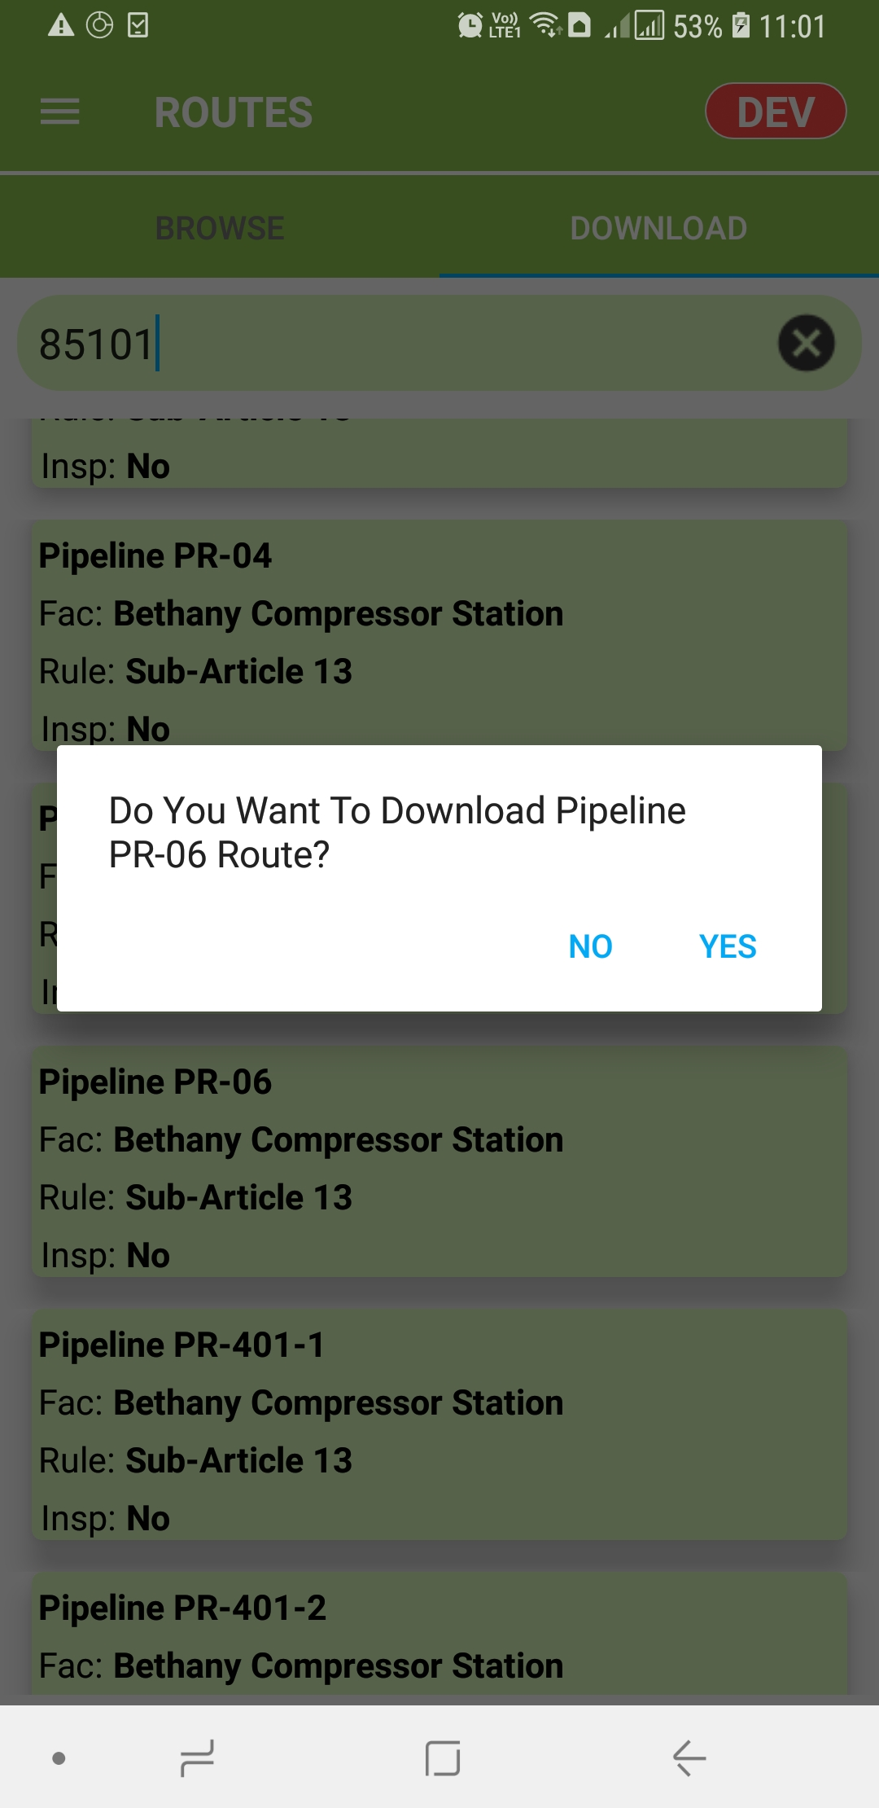
Wait for the Route to get downloaded. After download is completed the confirmation message - "<Name> Route has been downloaded successfully". Tap on Ok button.

Navigate to Download Tab on Routes Screen, to view the Downloaded Route.

> How to set Background Reading for Route?
Tap on Route, the bottom menu will appear. From the bottom menu tap to select "Route Background Reading".
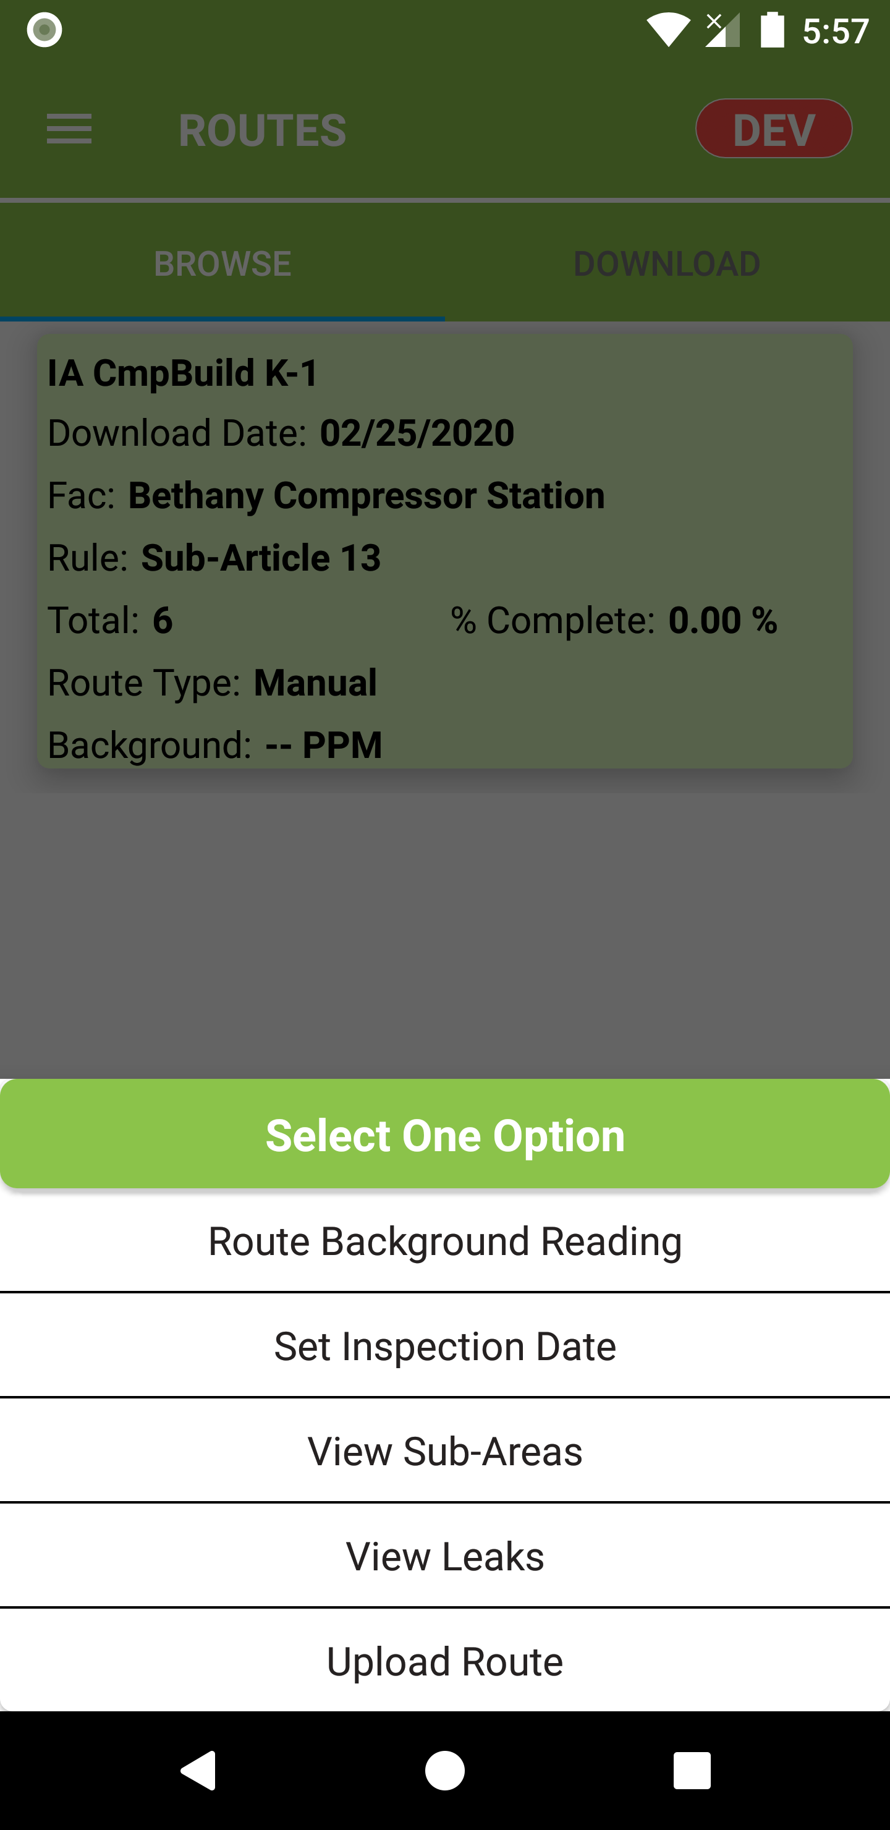

Enter the Max Reading and tap on Save button.

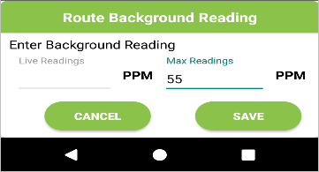
The entered background reading will be displayed for the Route.

> How to set Route Inspection Date?
Tap on Route, the bottom menu will appear. From the bottom menu tap to select "Set Inspection Date".

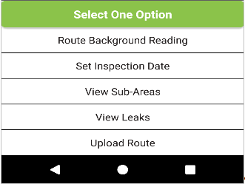
Enter the Inspection Date for the Route and tap on Save button.

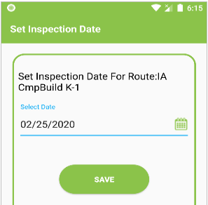
A confirmation message "Inspection Date is set successfully" is displayed. Tap on OK button.
The entered Inspection Date will be displayed for the Route.

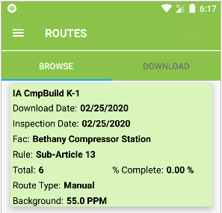

> How to view All / Inspected / UnInspected Subarea of Route?
Tap on Route, the bottom menu will appear. From the bottom menu tap to select "View Sub-Areas".
SubAreas screen will be displayed.

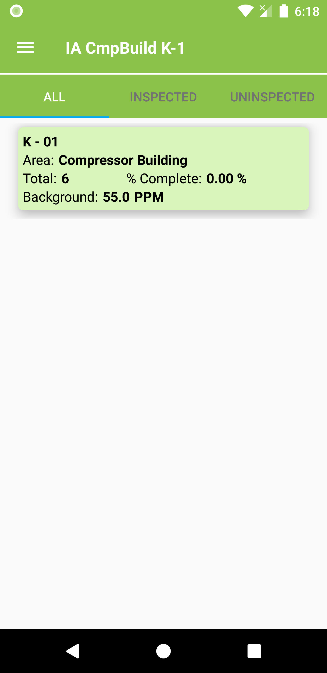

Default All SubAreas will be displayed.
Tap on Inspected / UnInspected to view respected SubAreas.

> How to set Background Reading for Subarea?
Tap on SubArea, the bottom menu will appear.

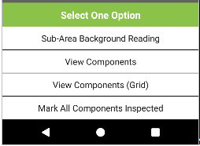

From the bottom menu tap to select "Sub-Area Background Reading".

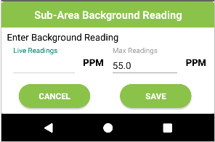
Enter the Max Reading and Tap on Save button.
The entered background reading will be displayed for SubArea.

> How to view Inspected / UnInspected Components for SubArea?
Tap on SubArea, the bottom menu will appear.
From the bottom menu tap to select "View Components" OR "View Components (Grid)".

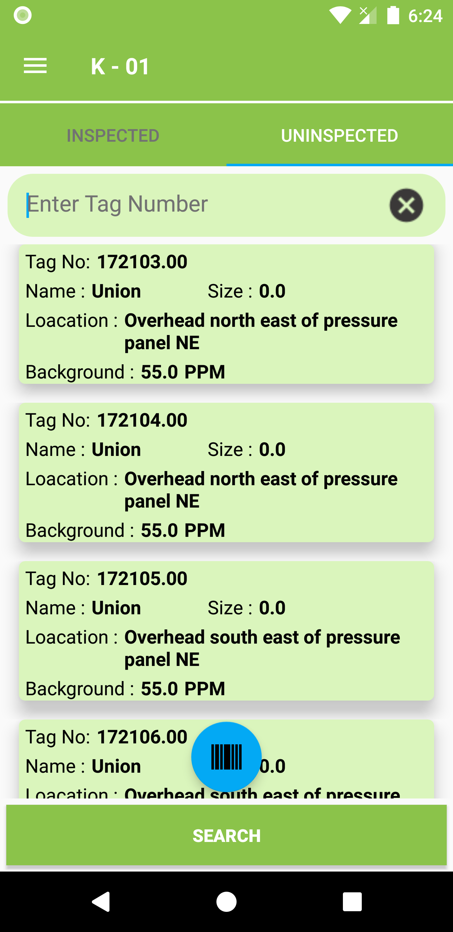

Default UnInspected Components screen will be displayed.
Tap on Inspected to view respective components.

> How to Mark All Components Inspected in SubArea?
Tap on SubArea, the bottom menu will appear. From bottom menu tap to select "Mark All Components Inspected". A confirmation message "Do you want to Mark All Components As Inspected. Tap on Yes button to proceed.

.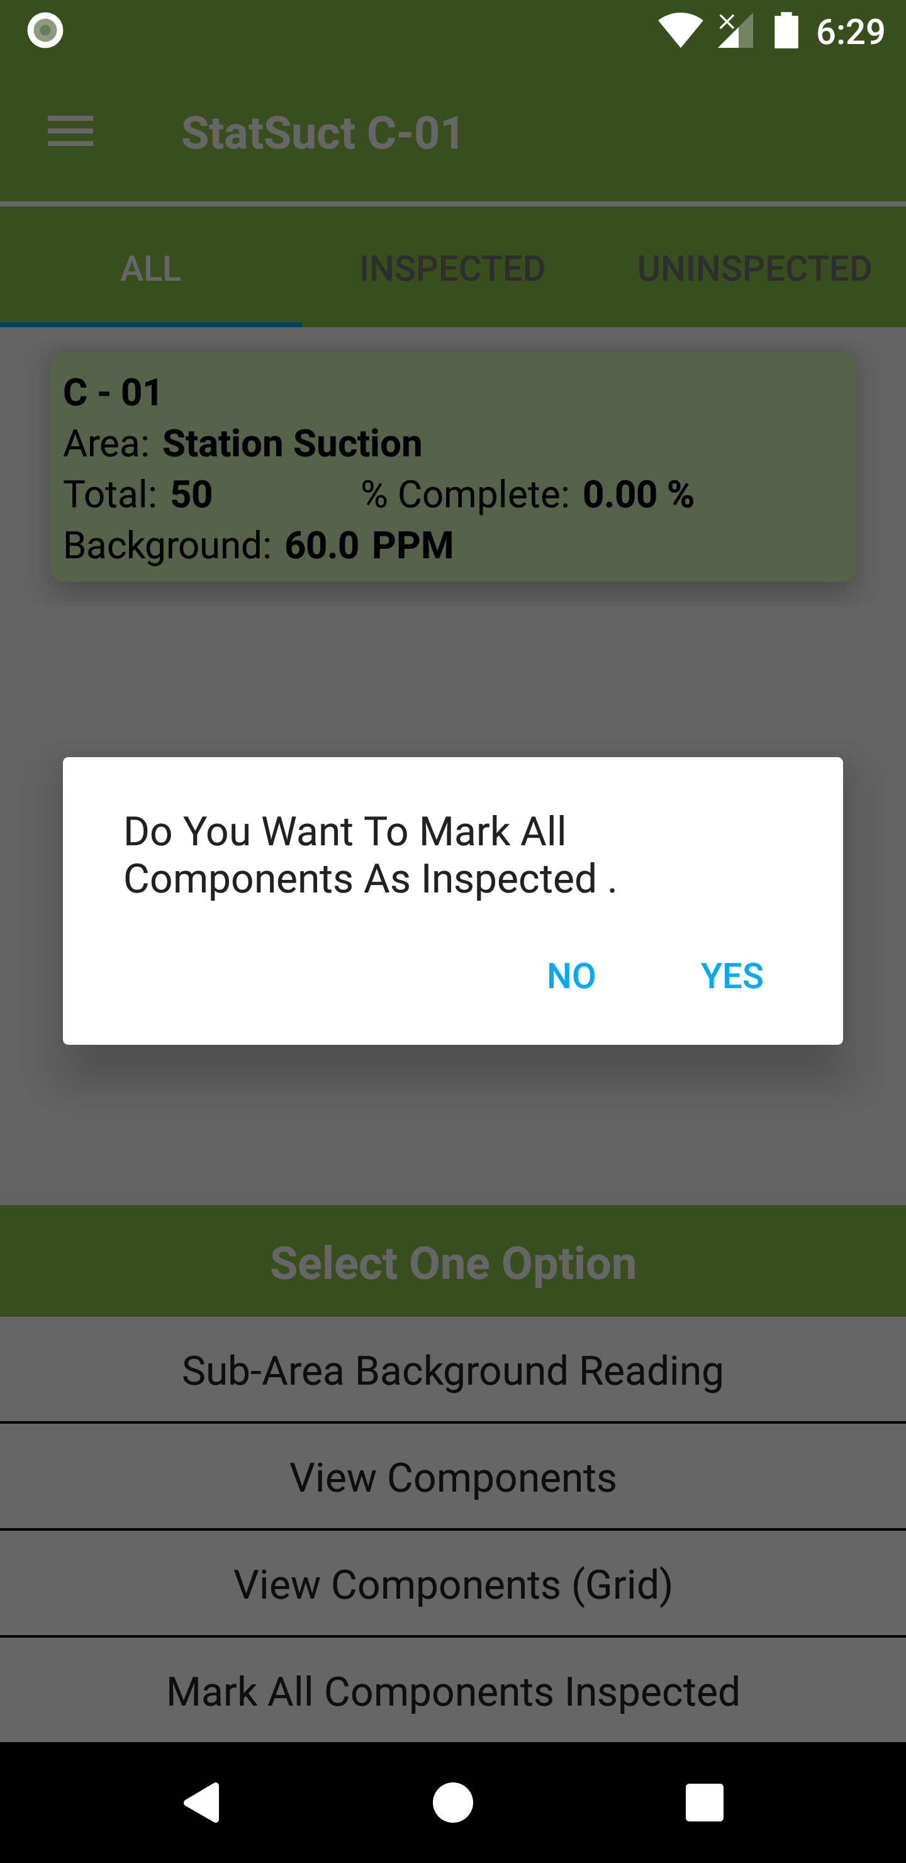

SubArea will be check marked as Inspected.

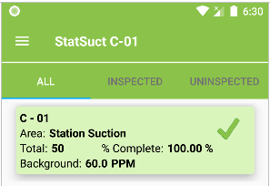

> How to search for Component?
On Component screen, use barcode to scan component tag or enter the barcode tag number in textbox.
Tap on Search button on keypad to find component in the list.

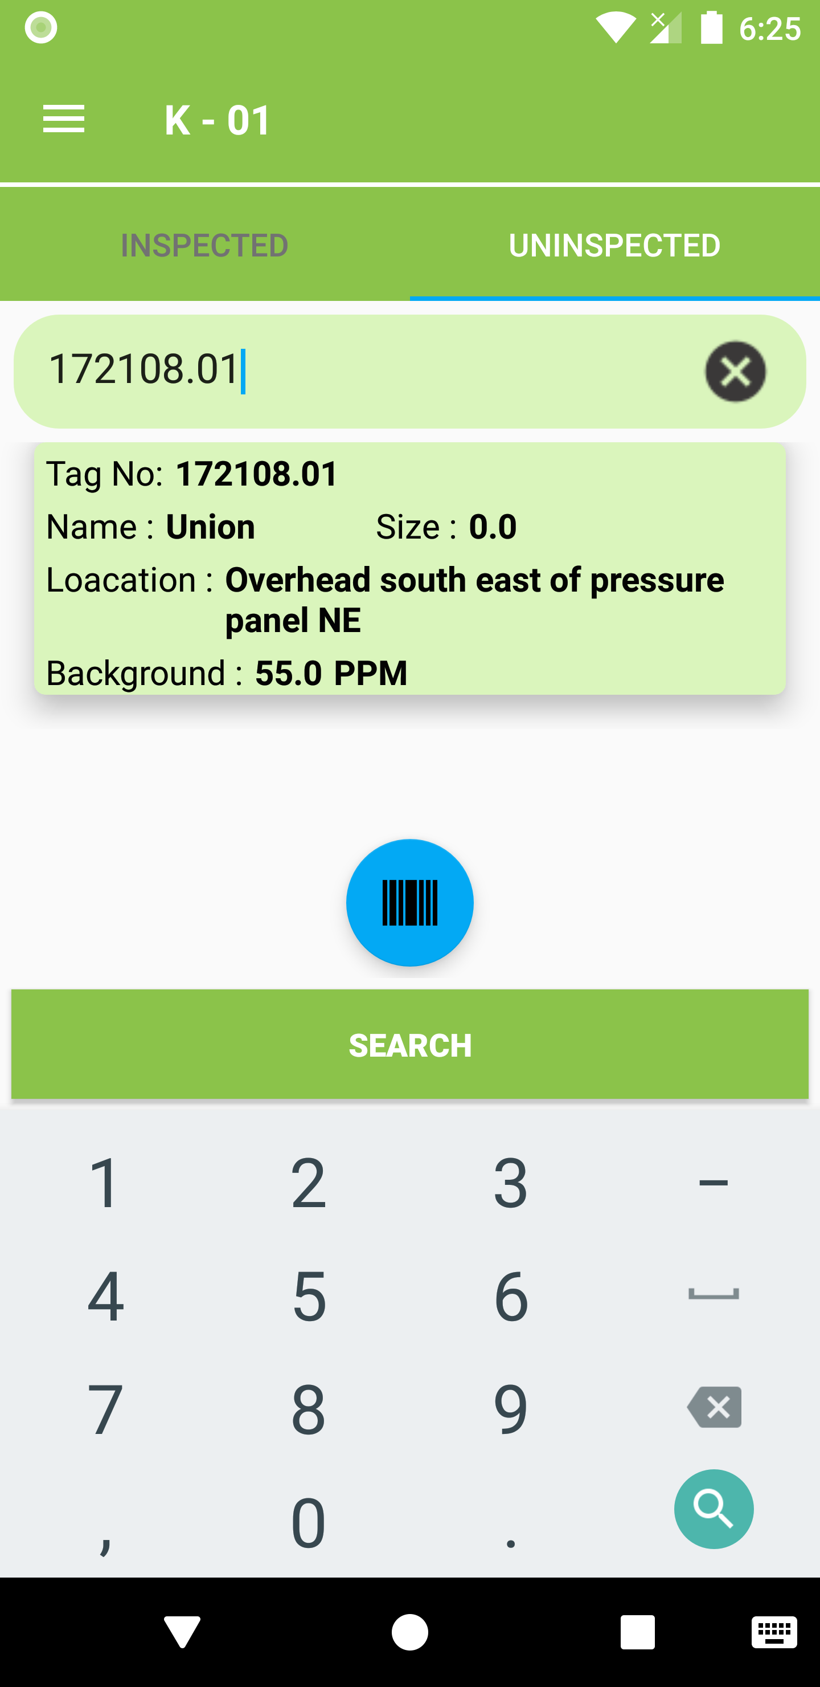

> How to enter Screening Value for Components?
On Component screen, tap on component to navigate to Screening Value screen.

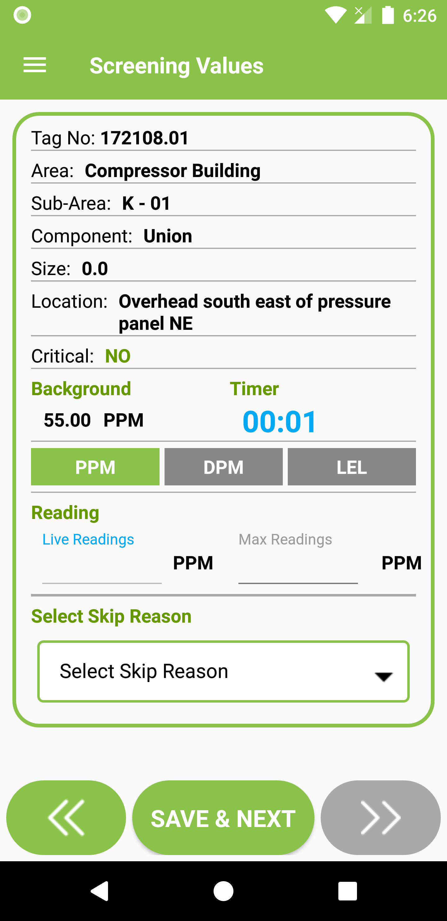

On Screening Value screen, enter the Max Readings or Select Skip Reason from drop down.
Tap on Save & Next button.
The app will determine, if the component is leaking and prompt with message – "A Leak has been identified !! Navigating to Leak Summary". Tap on Ok button to proceed.

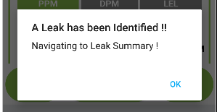

> How to enter Component Leak Summary?
When a leak is identified on Screening value screen, user will be navigated to Leak Summary Screen.

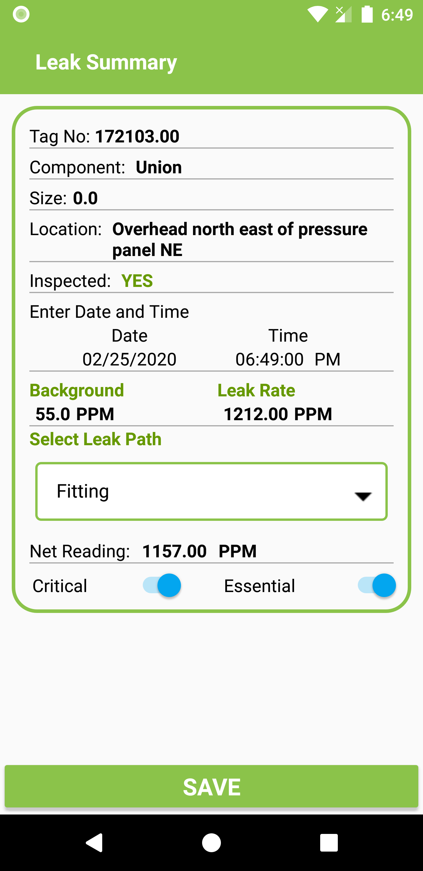

On Leak Summary screen, Select Leak Path. Change the Time, Critical and Essential as required.
Tap on save button to save the leak.

Saving Leak is mandatory. And cannot navigate away from screen without saving the leak.

> How to enter Component Leak Repairs?
On Leak Summary screen, after the leak is saved a prompt message to enter a repair is displayed.

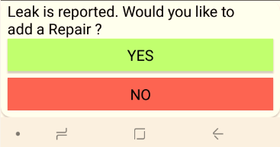
Tap on Yes to navigate to Leak Repairs screen.

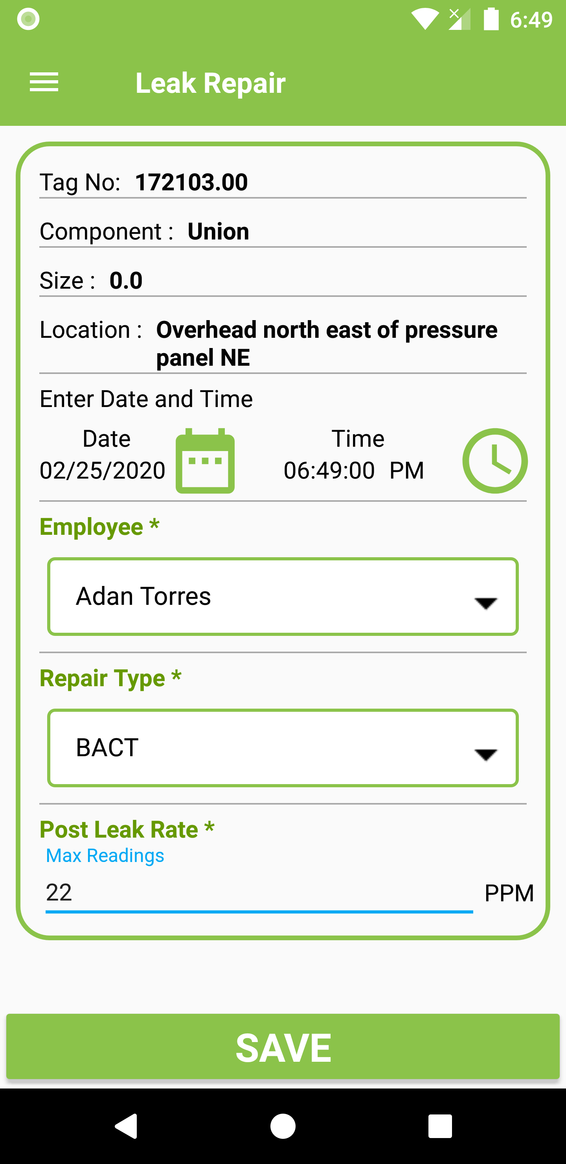
On Leak Repair Screen, Select Employee name, Repair Type, Set Time and Enter Post Leak Rate.
Tap on Save button.

> How to upload DAEP Route?
After DAEP Inspection, Tap on Route and select Upload Route from bottom menu.

On Inspection screen, Select Inspection for which Route needs to be uploaded.

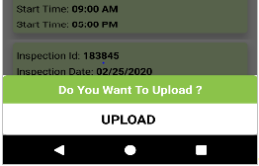
On bottom menu, tap to select Upload. Route will get uploaded against the selected inspection.
Wait for Route to get uploaded. Prompt message Route has been uploaded successfully will be displayed.
The Inspection Date of Route and Date of Inspection should be the same.

> How to upload Manual Route?
After manual inspection, Tap on Route and select Upload Route from bottom menu. Message prompted will be - “Route not Inspected Do you want to mark all components as Inspected and proceed”. Tap on Yes button to proceed to Inspection screen.

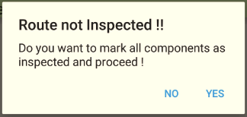

> How to create New Inspection?
On Inspections screen, Tap on " + " button on bottom of screen to navigate to Add Inspection Screen.

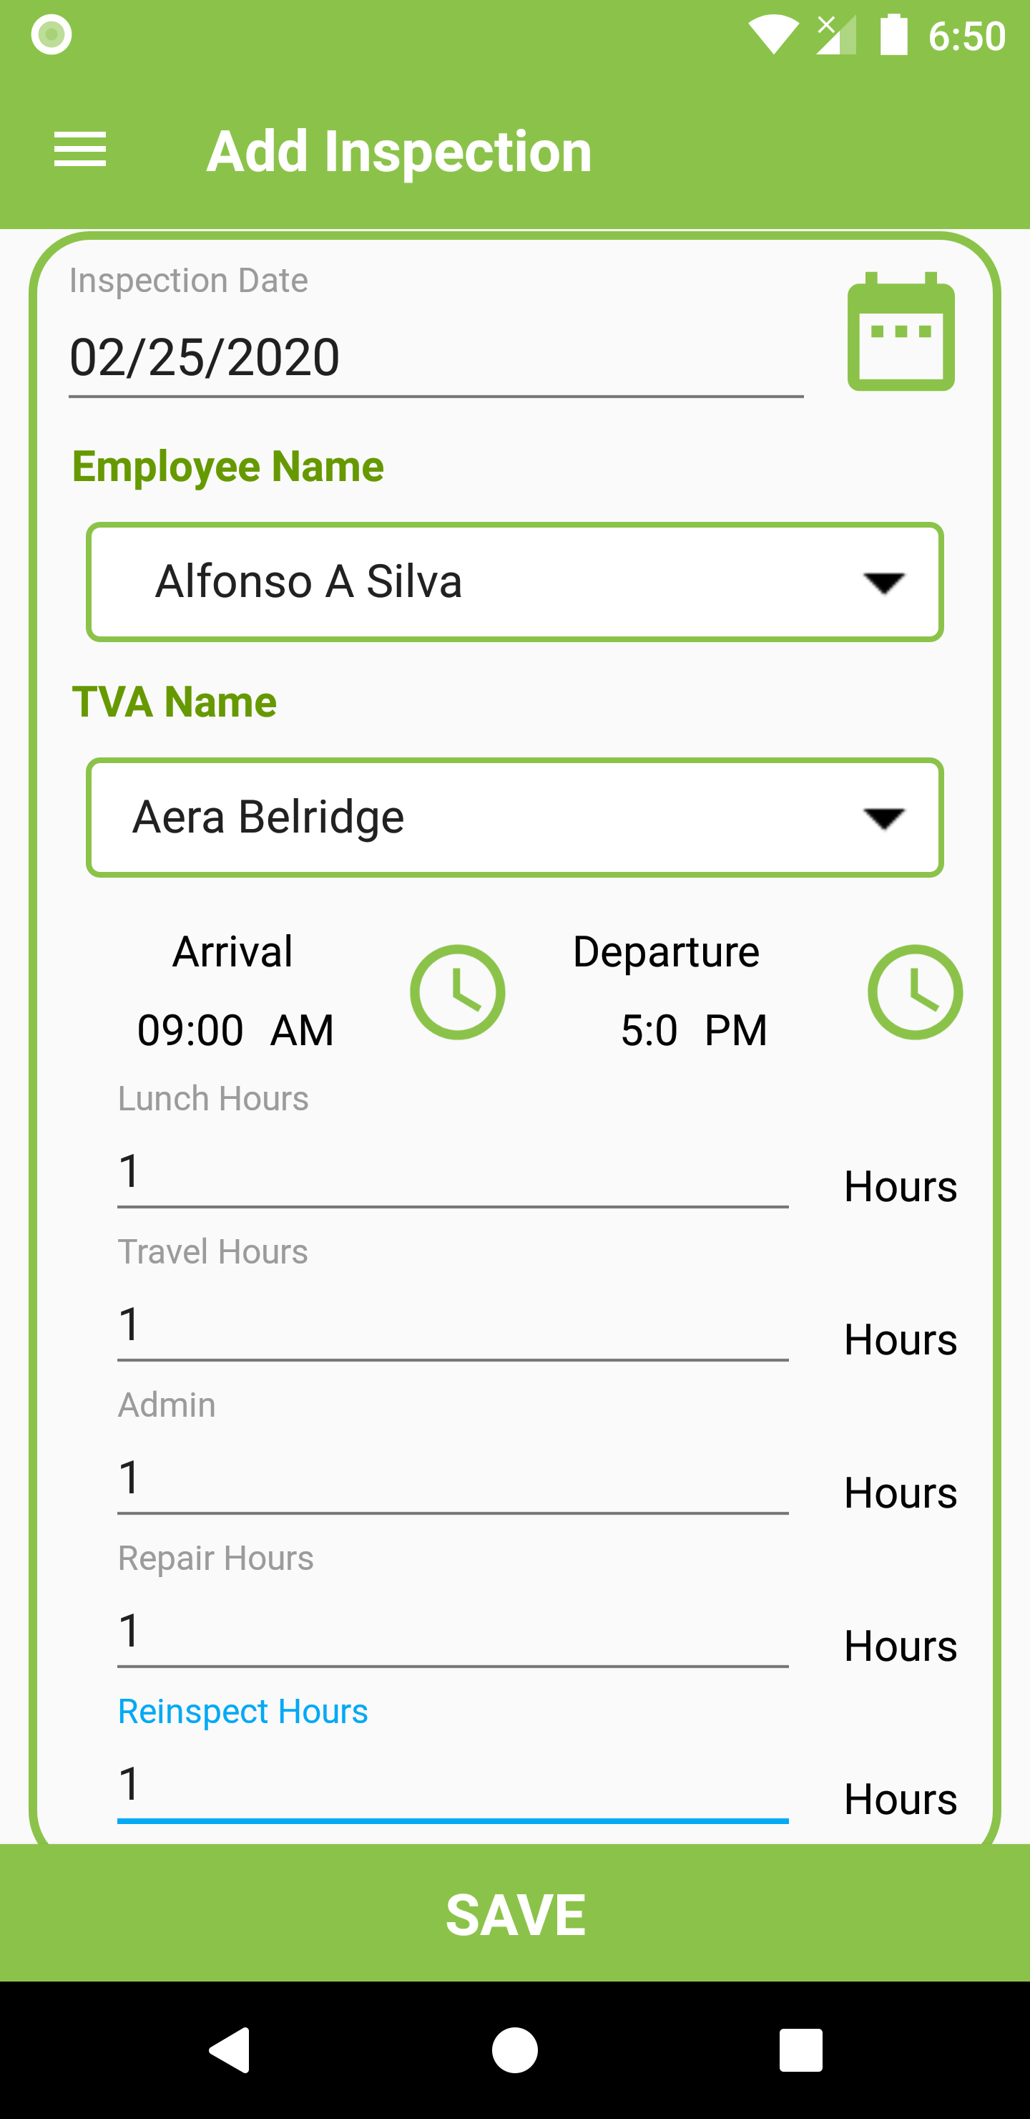

On Add Inspection screen, Select Date of Inspection, Employee Name, TVA Name, Arrival Time, Departure Time, Lunch Hours, Travel Hours, Admin Hours, Repair Hours and Re-inspect Hours.
Tap on Save button.

> How to pair TVA with Handheld Mobile Device?
On your mobile hand held device, Tap on bluetooth icon.

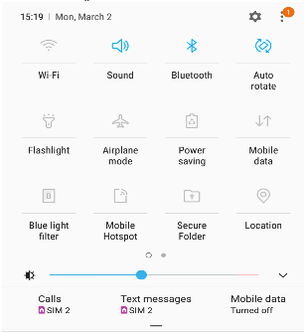
From list of available devices Tap on the TVA name to be paired.
Enter the default TVA pairing pass-code (0000 or 1234) to complete the pairing.
Paired TVA will appear in list of Paired Devices.

> How to connect paired TVA with Handheld Mobile Device?
On Home screen, Tap on Navigation Drawer and tap to select TVA Connect.
TVA Bluetooth Configuration screen will appear.

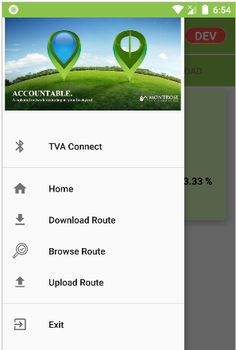

Select TVA from list of paired devices and connection process will start.
After successful connection prompt message will be displayed.

